You need to use the 32 bit version of java.

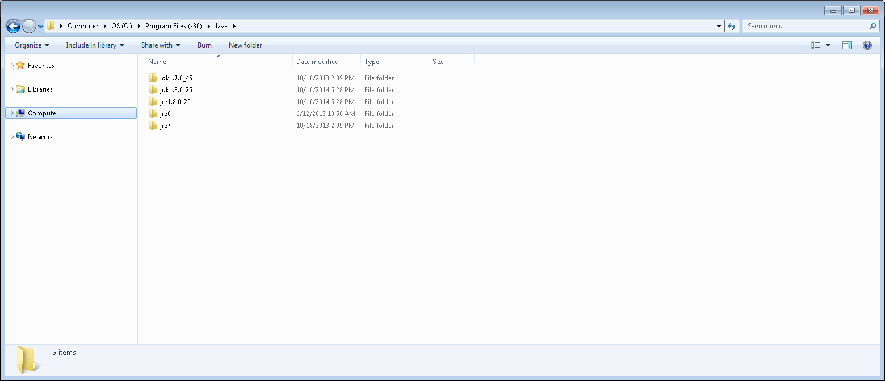

If you don’t have a Java folder in C:\Program Files (x86)\ , then install jre in the Installers folder

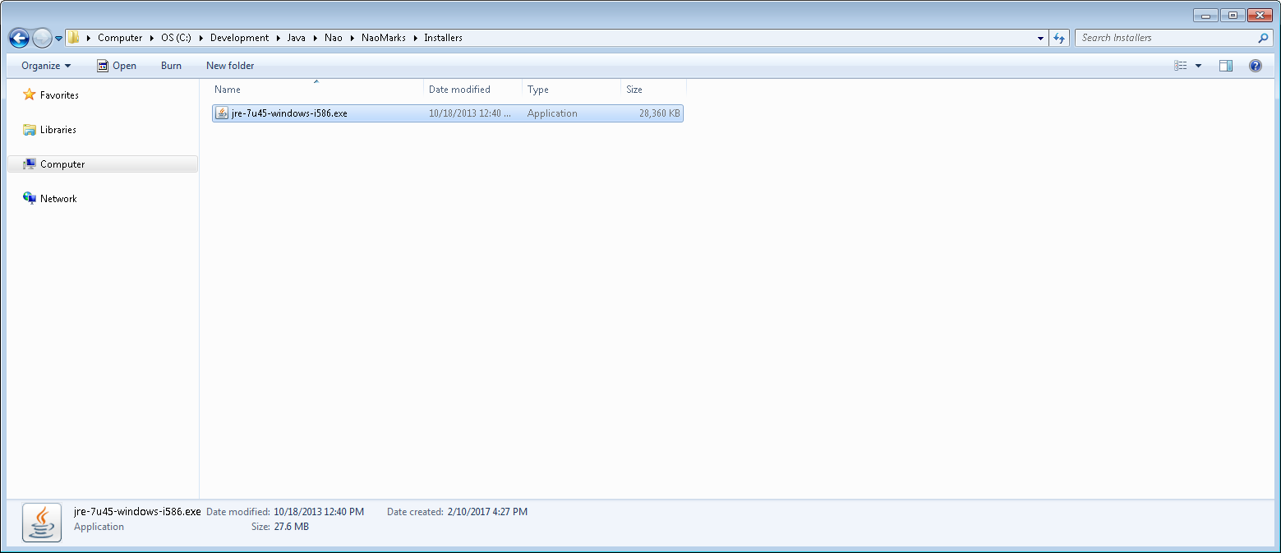

Now right click NaoMarks.cmd file and select Edit

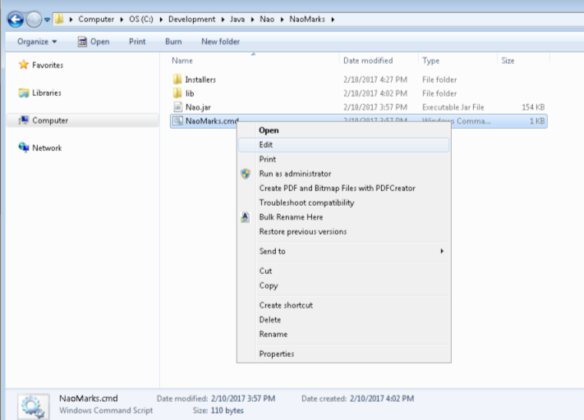

Change the path to java.exe to the version you are using

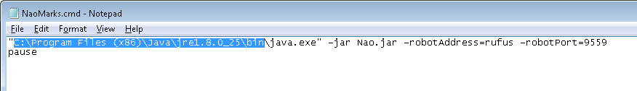

Change the name rufus to the name of your NAO robot or the IP address or your NAO robot.

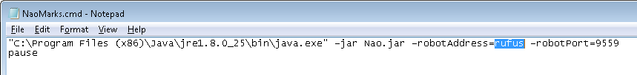

Change the port to whatever port number you are using, the default port is 9559. If using the default port, you don’t have to use the –robotPort= argument.

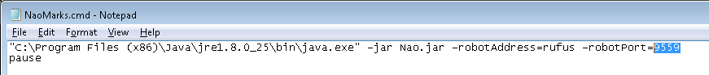

Save and close NaoMarks.cmd and then double click NaoMarks.cmd to run it.

You should see this. Click on the image to have robot center its gaze at where you clicked.

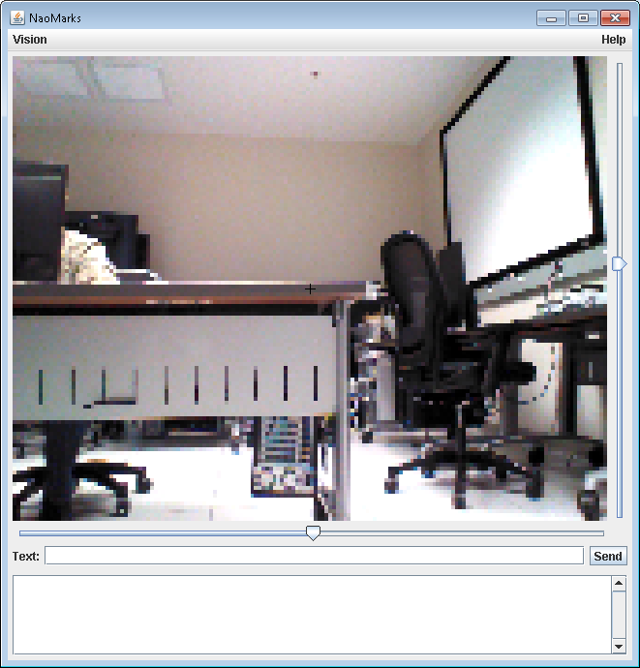 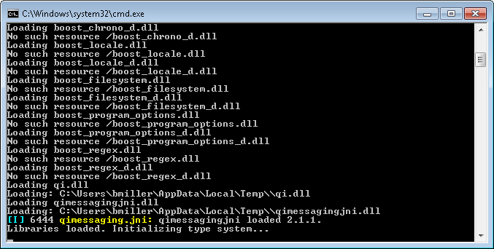

Type in the Text field and press enter to get the robot to talk.

